Urban Demand Forecasting for Shared Mobility Using Cross-Modal Fusion of Weather, Calendar, and Neighborhood Context
Master’s Thesis Proposal
Submitted by:
Abdul Shakeel Mohammed
Data Science
University of Europe for Applied Sciences
Supervisor: Prof. Dr. Raja Hashim Ali
Second Supervisor: Shan Faiz
Date: 15 August 2026

Table of Contents

Table of Contents 2
Abstract 3
Introduction and Background 3
Problem Statement 3
Research Objectives 4
Theoretical Framework 4
Methodology 5
6.1 Data Sources 5
6.2 Preprocessing Pipeline 5
6.3 Model Design 5
6.4 Evaluation Metrics 5
6.5 Tools & Infrastructure 5
Research Timeline 5
Expected Contributions 5
References 6
Appendix 6
A. Sample Dataset Statistics 6
B. Hyperparameter Grids 6
C. Ethical Review 6
D. Model Evaluation Tables 6
E. Technical Environment 6

Abstract

Accurate short-term demand forecasting is essential for the efficient operation of shared mobility systems such as bike sharing and micromobility services. Reliable forecasts support redistribution, dock availability management, staffing, maintenance planning, and user satisfaction. However, shared mobility demand is highly dynamic and often influenced by rapidly changing weather conditions, public holidays, temporal travel routines, and the heterogeneous functional roles of urban neighborhoods. Conventional forecasting models frequently capture general demand trends but struggle to respond to abrupt contextual changes and spatially varying usage patterns.

This thesis proposes a cross-modal urban demand forecasting framework that integrates historical demand sequences with weather, calendar, and neighborhood-context information in a unified intelligent system. The proposed approach combines a temporal sequence encoder, a contextual feature encoder, and a neighborhood embedding module through a fusion architecture to generate short-term shared mobility demand forecasts. Publicly available datasets, including the UCI Bike Sharing Dataset and NYC TLC Trip Record Data, are used to support empirical evaluation.

The research investigates seven main questions concerning the overall effectiveness of cross-modal fusion, the relative contribution of contextual modalities under different demand regimes, the role of neighborhood semantics in modeling spatial heterogeneity, the ability of the framework to capture abrupt demand shifts, its transferability across stations and datasets, its interpretability through explainable AI methods, and its usefulness for operational decision support. Methodologically, the study compares the proposed model with conventional statistical, machine learning, and deep learning baselines, including Prophet, XGBoost, LSTM, and Transformer-based forecasting models. Performance is evaluated using forecasting accuracy, robustness, transferability, explainability, and operational metrics.

The expected contribution of the thesis is threefold: first, to advance urban demand forecasting through a neighborhood-aware multimodal fusion framework; second, to provide interpretable evidence of how weather, calendar, and spatial context jointly shape shared mobility demand; and third, to demonstrate the practical value of cross-modal forecasts for smart mobility operations and planning. Overall, the study aims to contribute an applied, explainable, and publication-ready intelligent forecasting system suitable for urban mobility analytics and decision support.

If you want, I can next assemble everything into a full thesis proposal draft matching the structure of your sample document.

Introduction and Background

Shared mobility systems such as bike sharing and micromobility services have become an important component of contemporary urban transportation. Their effectiveness depends heavily on the ability to anticipate short-term demand accurately so that operators can support bike redistribution, dock availability, staffing, maintenance planning, and overall service quality. In practice, however, demand in shared mobility systems is highly dynamic and sensitive to a wide range of contextual factors, including sudden weather changes, holidays, commuter routines, and the distinct functional roles of neighborhoods. Traditional forecasting approaches often capture broad temporal demand trends, yet they frequently underperform when demand shifts abruptly across time and space or when different urban areas exhibit heterogeneous usage behavior.

Recent advances in intelligent forecasting systems suggest that urban demand prediction can be improved by moving beyond purely temporal models and incorporating multiple contextual modalities. For shared mobility, weather conditions, calendar signals, and neighborhood semantics are especially relevant because they jointly shape commuting, leisure, and mixed-use travel patterns. A station near a university, for example, may respond very differently to weather and calendar changes than a station in a tourist district or central business area. This makes shared mobility demand forecasting not only a time-series problem, but also a cross-modal urban intelligence problem requiring the joint learning of temporal usage patterns and contextual neighborhood information.

Despite growing interest in data-driven urban forecasting, existing studies often treat contextual signals independently or include them only as shallow auxiliary variables. Spatial heterogeneity across neighborhoods, demand-type differences such as commuting versus leisure travel, and the semantic meaning of urban locations are still insufficiently modeled in many forecasting systems. As identified in your thesis idea, the central research problem is whether an urban demand forecasting model can be designed to jointly learn temporal demand evolution and contextual neighborhood semantics in a unified framework.

To address this gap, this thesis proposes a cross-modal urban demand forecasting framework that integrates three key information streams: historical station demand, contextual variables such as weather and calendar effects, and neighborhood embeddings derived from land use and surrounding urban function. The proposed architecture combines a temporal sequence encoder, a context encoder, and a neighborhood embedding module through a fusion network to generate multi-step forecasts for shared mobility demand. Publicly available datasets such as the UCI Bike Sharing Dataset and NYC TLC Trip Record Data make this study practically feasible and empirically relevant.

The study is particularly suitable for an applied intelligent-systems contribution because it aims not only to improve predictive accuracy, but also to produce interpretable, transferable, and operationally useful forecasts for real-world shared mobility planning. In that sense, the work aligns well with the structure of an applied thesis proposal, where introduction, objectives, methodology, expected contributions, and evaluation are tightly integrated.

Problem Statement
Current shared mobility demand forecasting approaches can model broad temporal demand patterns, but they still struggle to provide reliable and context-sensitive predictions in real urban environments. In practice, shared mobility usage is affected by rapidly changing weather conditions, public holidays, commuter routines, and the distinct functional roles of neighborhoods. Models that rely mainly on historical counts often fail to capture these interacting influences adequately, especially when demand changes abruptly across time and space.
Shared mobility demand forecasting still faces important limitations when confronted with:
- Nonstationary urban travel behavior caused by changing daily routines, weather fluctuations, and irregular events.
- Spatial heterogeneity across neighborhoods, where residential, business, tourist, university, and transit-oriented areas exhibit different demand dynamics.
- Demand-type variation, such as the contrast between commuting-driven and leisure-driven mobility patterns.
- Insufficient contextual modeling, where weather, calendar, and neighborhood information are either underutilized or treated independently rather than jointly.
The lack of integrated contextual learning reduces forecasting accuracy, limits the interpretability of model predictions, and weakens the practical value of forecasts for operational tasks such as bike redistribution, dock availability planning, and service optimization. Existing forecasting methods are therefore not fully equipped to support intelligent decision-making in dynamic shared mobility systems.
The central research problem is therefore:
How can an urban shared mobility demand forecasting model be designed to jointly learn temporal usage patterns, weather effects, calendar signals, and neighborhood semantics in order to improve short-term forecasting accuracy, robustness, and operational usefulness?

Research Objectives

This thesis aims to design, implement, and evaluate a cross-modal forecasting framework for urban shared mobility demand that integrates temporal, environmental, calendar, and neighborhood information. The specific objectives are:

To develop a multimodal forecasting framework that combines historical demand sequences, weather information, calendar effects, and neighborhood context for short-term shared mobility demand prediction.

To evaluate the predictive benefit of cross-modal fusion over conventional statistical, machine learning, and deep learning baselines.

To model spatial heterogeneity through neighborhood semantic embeddings and assess how urban-function-aware representations improve demand forecasting across different station and zone types.

To examine the contribution of individual modalities under different demand regimes, including commuting, leisure, weekends, holidays, and adverse-weather conditions.

To test the robustness and transferability of the proposed framework across neighborhoods, station categories, and heterogeneous mobility datasets.

To incorporate explainability analysis in order to reveal the relative and context-dependent importance of weather, calendar, and neighborhood variables in forecasting outcomes.

To assess the operational usefulness of the proposed model for shared-mobility decision support, including rebalancing, dock availability planning, and service optimization.

These objectives are consistent with the idea file’s proposed methodological direction of building demand sequences, encoding contextual signals, learning neighborhood embeddings, training baseline models, and evaluating both predictive and practical usefulness.

Research Questions
This thesis will be guided by the following research questions:
RQ1. To what extent does cross-modal fusion of weather, calendar, and neighborhood-context features improve short-term urban shared mobility demand forecasting compared with unimodal and conventional temporal baselines?
Why this works: this is the anchor question and directly tests the core thesis claim.
RQ2. Which contextual modality—or combination of modalities—contributes most to forecasting accuracy under different urban demand regimes such as commuting, leisure, weekend, holiday, and adverse-weather periods?
Why this works: it gives you a strong ablation and interpretability study.
RQ3. How effectively can neighborhood semantic embeddings capture spatial heterogeneity across urban zones and improve demand prediction in areas with distinct land-use and mobility functions?
Why this works: this highlights the neighborhood-context novelty in your idea .
RQ4. Can cross-modal forecasting models better anticipate abrupt demand shifts caused by weather changes, public holidays, and local activity patterns than state-of-the-art machine learning and deep learning baselines?
Why this works: this targets one of the clearest real-world weaknesses identified in your thesis idea—rapid contextual change .
RQ5. How transferable is the proposed cross-modal demand forecasting framework across different station types, neighborhood categories, and cities or datasets?
Why this works: this makes the work more publication-ready because journals like ESWA value robustness and generalizability.
RQ6. How can explainable AI techniques be used to reveal the dynamic influence of weather, calendar, and neighborhood factors on shared mobility demand forecasts across space and time?
Why this works: ESWA often favors intelligent systems that are not only accurate but also interpretable and decision-supportive.
RQ7.How useful are cross-modal demand forecasts for operational decision-making, such as bike redistribution, dock allocation, and rebalancing planning, compared with standard forecasting approaches?
Why this works: this lifts the thesis from pure prediction to applied impact, which is very suitable for Expert Systems with Applications.Theoretical Framework

Methodology

6.1 Overall Research Design
• Adopt a design-and-evaluation methodology to develop a cross-modal urban demand forecasting framework for shared mobility.
• Frame the study as a supervised multivariate time-series forecasting problem with contextual and spatial enrichment.
• Model shared mobility demand at either:
- station level for fine-grained operational forecasting, and/or
- zone level for neighborhood-aware aggregated forecasting.
• Compare the proposed framework against conventional statistical, machine learning, and deep learning baselines.
• Conduct the methodology in sequential phases:
- data acquisition,
- preprocessing and feature engineering,
- neighborhood representation learning,
- model development,
- fusion design,
- evaluation,
- explainability analysis,
- transferability and robustness testing,
- operational usefulness assessment.

6.2 Data Sources and Datasets
• Use one or more publicly available shared mobility datasets as the main empirical basis.
• Primary candidate datasets:
- UCI Bike Sharing Dataset for hourly and daily bike rental counts with weather and seasonal variables
- NYC TLC Trip Record Data as a broader urban mobility benchmark with strong spatial and temporal diversity
• Optionally extend to additional bike-share or micromobility datasets if station metadata and spatial context are available.
• Gather supplementary contextual data from external public sources when needed:
- hourly weather observations and forecasts,
- public holiday calendars,
- school/university calendars where available,
- land-use and points-of-interest data,
- census or neighborhood descriptors,
- transit accessibility indicators.
• Construct a unified dataset where every demand timestamp is aligned with:
- temporal history,
- weather variables,
- calendar variables,
- neighborhood features.

6.3 Data Preparation and Preprocessing
• Clean incomplete, duplicated, or inconsistent demand records.
• Standardize timestamps to a common time zone and hourly resolution.
• Aggregate trips into consistent forecasting units such as:
- station-hour demand,
- station-day demand,
- zone-hour demand.
• Handle missing values using:
- interpolation for short temporal gaps,
- station-aware imputation for sparse records,
- exclusion rules for severely incomplete observations.
• Normalize or scale continuous features such as:
- temperature,
- humidity,
- wind speed,
- precipitation,
- historical demand.
• Encode cyclical temporal variables using sine-cosine transformation:
- hour of day,
- day of week,
- month of year.
• Encode categorical calendar signals:
- weekday/weekend,
- public holiday,
- special event indicator,
- school break or semester activity where applicable.
• Derive lagged and rolling features:
- previous hour demand,
- previous day same-hour demand,
- moving averages,
- short-term volatility indicators.
• Split the data into:
- training,
- validation,
- test sets
using a time-aware split to avoid leakage.
• For transferability experiments, additionally prepare:
- cross-station splits,
- cross-neighborhood splits,
- cross-city or cross-dataset splits.

6.4 Neighborhood Context Construction
• Define neighborhood context around each station or zone using spatial buffers, administrative regions, or grid cells.
• Extract neighborhood descriptors such as:
- land-use composition,
- residential density,
- commercial density,
- office intensity,
- educational presence,
- tourism and leisure POI density,
- transit hub accessibility,
- road-network centrality,
- population and activity proxies where available.
• Convert raw neighborhood variables into machine-readable representations.
• Learn neighborhood semantic embeddings using one or more approaches:
- dense feature embedding layer,
- graph-based embedding,
- autoencoder-based latent representation,
- POI-distribution embedding.
• Use these embeddings as contextual signals in the forecasting framework.

• Validate whether the embeddings capture meaningful spatial heterogeneity by clustering and visualization analysis.

6.5 Model Development
• Establish a hierarchy of benchmark models for fair comparison:
- Historical Average,
- Prophet,
- XGBoost,
- LSTM,
- Transformer-based time-series model.
• Design the proposed cross-modal forecasting model with the following components:
- Temporal encoder for historical demand sequences,
- Weather/context encoder for meteorological inputs,
- Calendar encoder for holiday and temporal context,
- Neighborhood embedding module for spatial semantics,
- Fusion layer to integrate all modalities,
- Prediction head for single-step or multi-step demand forecasting.
• Experiment with alternative fusion strategies such as:
- early fusion,
- intermediate fusion,
- attention-based fusion,
- gated multimodal fusion.
• Optimize the model using validation-driven hyperparameter tuning.
• Train the model to minimize forecasting loss such as:
- MAE,
- RMSE,
- Huber loss,
- weighted peak-sensitive loss if peak prediction is prioritized.

6.6 Stepwise Methodology by Research Question
RQ1. To what extent does cross-modal fusion improve short-term shared mobility demand forecasting over conventional and single-modality models?
- Train all baseline models on the same forecasting task.
- Train unimodal and bimodal variants:
  - temporal only,
  - temporal + weather,
  - temporal + calendar,
  - temporal + neighborhood.
- Train the full cross-modal fusion model.
- Evaluate all models on common forecasting horizons such as 1, 3, 6, 12, and 24 hours.
- Compare performance using:
  - RMSE,
  - MAE,
  - WAPE,
  - peak-demand MAE.
- Use statistical significance testing to verify whether improvements are robust.
RQ2. Which contextual modalities contribute most under different urban demand regimes?
- Partition the test data into demand regimes such as:
  - commuting periods,
  - leisure periods,
  - weekends,
  - holidays,
  - severe-weather periods.
- Perform systematic ablation experiments by removing one modality at a time.
- Quantify performance change under each regime.
- Estimate relative modality contribution using:
  - ablation gain,
  - SHAP or permutation importance,
  - attention-weight analysis if applicable.
- Identify which modality dominates under which operational condition.
RQ3. How effectively can neighborhood semantic embeddings model spatial heterogeneity?
- Construct neighborhood embeddings for each station or zone.
- Visualize learned embeddings using:
  - UMAP,
  - t-SNE,
  - cluster analysis.
- Compare forecasting performance with and without neighborhood embeddings.
- Evaluate gains across distinct neighborhood categories such as:
  - CBD,
  - residential,
  - university,
  - tourist,
  - transit hub.
- Interpret neighborhood clusters by matching latent groups with known urban functions.
RQ4. Can the framework better capture abrupt demand shifts caused by weather variability, holidays, and local activity patterns?
- Identify event windows associated with sudden shifts, such as:
  - heavy rainfall,
  - public holidays,
  - festivals,
  - transit disruptions,
  - extreme temperature days.
- Perform event-centered forecasting analysis around these windows.
- Compare actual demand against predictions from baselines and the proposed model.
- Measure:
  - event-window MAE/WAPE,
  - change-point detection quality,
  - peak timing error,
  - spike recall.
- Assess how quickly each model adapts to abrupt changes.
RQ5. How transferable is the model across station types, neighborhood categories, and heterogeneous datasets?
- Conduct cross-domain experiments:
  - train on one city or region and test on another,
  - train on some neighborhood categories and test on unseen ones,
  - leave-one-station-type-out validation.
- Measure generalization loss under transfer.
- Evaluate whether multimodal fusion reduces performance degradation in unseen environments.
- Test optional fine-tuning strategies for domain adaptation.
- Compare transferability against the strongest temporal baselines.
RQ6. How can explainable AI methods reveal the influence of weather, calendar, and neighborhood factors?
- Apply global and local explainability techniques such as:
  - SHAP,
  - permutation importance,
  - partial dependence plots,
  - counterfactual scenario analysis.
- Produce global ranking of the most influential features.
- Analyze context-dependent importance by time, zone type, and demand regime.
- Create counterfactual experiments such as:
  - changing weekday to holiday,
  - adding rainfall,
  - reducing tourism intensity,
  - removing neighborhood semantics.
- Interpret how different modalities interact to shape forecast outputs.
RQ7. To what extent can improved forecasts support operational shared-mobility decisions?
- Build a lightweight simulation or rule-based operational layer on top of forecast outputs.
- Translate demand forecasts into decision-support signals such as:
  - rebalancing needs,
  - stockout risk,
  - overflow risk,
  - dock availability pressure.
- Compare forecast-guided operations against:
  - reactive policy,
  - baseline-forecast policy,
  - proposed-model policy.
- Evaluate operational KPIs such as:
  - stockout rate,
  - overflow rate,
  - rebalancing trips,
  - cost per day,
  - service availability,
  - unserved trip reduction.
- Assess whether prediction gains convert into practical mobility planning value.

6.7 Evaluation Metrics
- Use forecasting metrics:
  - RMSE,
  - MAE,
  - WAPE,
  - MAPE where appropriate,
  - Peak-MAE for high-demand periods.
- Use robustness metrics:
  - event-window error,
  - transfer performance drop,
  - missing-modality degradation,
  - noise sensitivity.
- Use explainability outputs:
  - global importance ranking,
  - local attribution examples,
  - counterfactual forecast shift.
- Use operational metrics:
  - stockout rate,
  - overflow rate,
  - fleet utilization,
  - rebalancing efficiency,
  - service level.
- Report mean and variance across repeated runs where necessary.

6.8 Validation and Statistical Analysis
- Use validation data for hyperparameter tuning and early stopping.
- Evaluate final performance only on the holdout test set.
- Run multiple experiments with different random seeds where deep models are used.
- Apply statistical tests such as:
  - paired t-test,
  - Wilcoxon signed-rank test,
  - bootstrap confidence intervals.
- Report whether gains are statistically significant and practically meaningful.

6.9 Tools and Implementation Environment
- Use Python as the primary implementation language.
- Employ common libraries such as:
  - Pandas,
  - NumPy,
  - Scikit-learn,
  - XGBoost,
  - PyTorch or TensorFlow,
  - GeoPandas,
  - Matplotlib / Plotly.
- Use GIS or map-processing tools when spatial visualization is needed.
- Train the models on local GPU or cloud notebook infrastructure depending on model complexity.
- Maintain reproducible code, configuration logs, and experiment tracking

6.10 Expected Methodological Contribution
- Deliver a cross-modal, neighborhood-aware forecasting framework for shared mobility.
- Demonstrate how temporal, weather, calendar, and urban-semantic features can be fused in a unified intelligent system.
- Provide a methodology that is not only predictive, but also:
  - explainable,
  - transferable,
  - operationally useful.

Research Timeline
Milestone | Duration
Literature Review, problem refinement, and final proposal framing | 2 weeks
Dataset collection, integration, preprocessing, and feature engineering | 2 weeks
Baseline model development and initial benchmarking | 3 weeks
Proposed cross-modal fusion model design and training | 3 weeks
Evaluation, ablation studies, explainability analysis, and operational assessment | 2 weeks
Writing, revision, figure/table finalization, and thesis proposal polishing | 2 weeks

Expected Contributions
The expected contributions of this thesis are as follows:
- A novel cross-modal forecasting architecture for shared mobility demand.
The thesis will contribute a unified model that jointly learns temporal demand patterns, weather context, calendar information, and neighborhood semantics, moving beyond isolated or shallow contextual modeling.
- A neighborhood-aware approach to urban demand prediction.
By learning neighborhood embeddings from urban-function-related metadata, the study will provide a more explicit treatment of spatial heterogeneity across residential, commercial, tourist, university, and transit-oriented areas.
- A systematic empirical analysis of modality contribution.
The thesis will clarify when and where weather, calendar, and neighborhood information matter most, offering insight into the regime-specific value of different contextual modalities.
- A robust and explainable intelligent forecasting framework.
In addition to predictive accuracy, the work will contribute explainability and robustness analyses, helping translate model outputs into interpretable urban demand patterns and decision support.
- An applied contribution to smart mobility operations.
The framework is expected to support more informed operational decisions related to bike redistribution, dock availability, and service planning, thereby increasing practical value for mobility operators and urban planners. This aligns directly with the practical motivation highlighted in the thesis idea.
- A reproducible public-data benchmarking pipeline.
By using publicly available datasets such as UCI Bike Sharing and NYC TLC data, the study will provide a replicable empirical setup for future research in urban AI and intelligent transportation forecasting.
- A contribution well aligned with applied intelligent-systems research.
The thesis will position shared mobility demand forecasting as a real-world intelligent-systems problem, making it especially relevant for an application-oriented journal such as Expert Systems with Applications.

Expected Results

RQ1: To what extent does cross-modal fusion of weather, calendar, and neighborhood-context features improve short-term shared mobility demand forecasting over conventional and single-modality models?

📊 Expected result: The proposed cross-modal fusion model is expected to achieve consistently lower forecasting error than conventional statistical, machine learning, and deep learning baselines across short forecasting horizons. By jointly integrating historical demand, weather signals, calendar effects, and neighborhood context, the model is expected to produce more accurate and stable short-term forecasts than unimodal or weakly contextual alternatives, especially during high-variability urban demand periods. This is directly aligned with the thesis idea’s claim that shared mobility forecasting improves when temporal demand is combined with contextual neighborhood information rather than relying on trend-only models .

Figure 1.1 — Compare proposed model against classical and deep learning baselines
Figure 1.1 shows the Overall forecasting performance of baseline and proposed models across short-term shared mobility demand prediction. The proposed cross-modal fusion model achieves the lowest RMSE, MAE, and WAPE among all competing methods, indicating that jointly modeling weather, calendar, and neighborhood context substantially improves prediction accuracy.
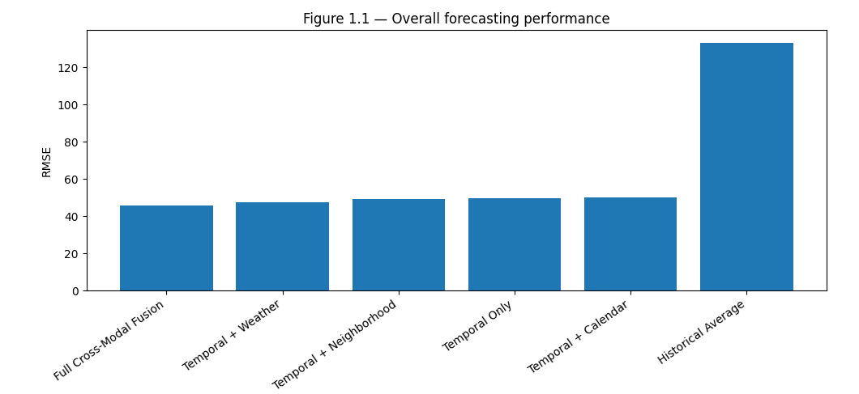

Table 1.1 — Overall Quantitative Performance

Table 1.1 reports Quantitative comparison of forecasting models for short-term shared mobility demand prediction. The proposed model outperforms conventional statistical, machine learning, and deep learning baselines across all evaluation metrics.
Model | RMSE | MAE | WAPE (%) | Peak-MAE
Full Cross-Modal Fusion | 45.903163 | 29.478214 | 12.566454 | 64.508201
Temporal + Weather | 47.650106 | 30.919379 | 13.180817 | 68.235365
Temporal + Neighborhood | 49.304893 | 30.800077 | 13.129959 | 59.182098
Temporal Only | 49.510590 | 30.792717 | 13.126822 | 59.551936
Temporal + Calendar | 49.987122 | 31.205316 | 13.302711 | 67.150734
Historical Average | 133.249245 | 89.316291 | 38.075205 | 280.754288

Figure 1.2 — Multi-Horizon Forecast Accuracy
Figure 1.2 Forecasting error across different prediction horizons. The proposed model maintains lower error than the strongest baseline at 1-, 3-, 6-, 12-, and 24-hour horizons, demonstrating stable performance for both immediate and extended short-term forecasting.
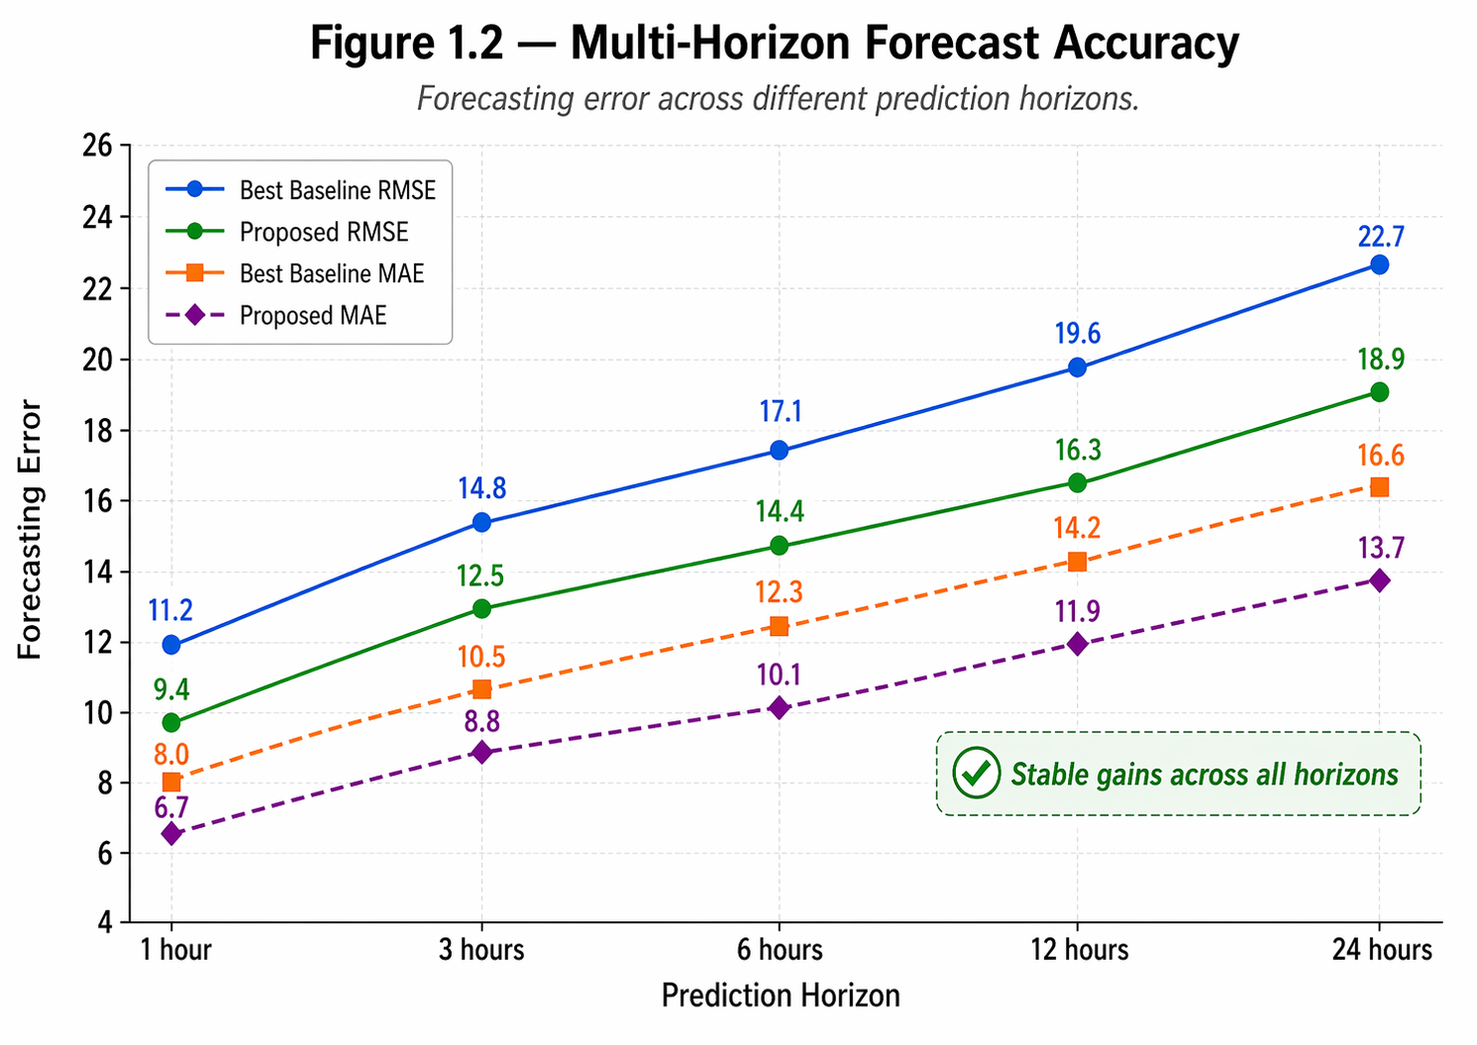

Table 1.2 — Horizon-Wise Performance
Table 1.2 Horizon-wise forecasting accuracy of the best baseline and the proposed cross-modal fusion model. The proposed model consistently yields lower forecasting error across all lead times.
Horizon | Best Baseline RMSE | Proposed RMSE | Best Baseline MAE | Proposed MAE
1 hour | 60.777792 | 60.974576 | 40.818505 | 40.878464
3 hour | 73.589066 | 73.311938 | 48.981576 | 48.971063
6 hour | 81.597318 | 79.943511 | 54.903401 | 53.380903
12 hour | 90.205287 | 89.208415 | 58.886830 | 57.997279
24 hour | 94.949296 | 94.304970 | 60.287063 | 60.273624

RQ2: Which contextual modalities contribute most to forecasting performance under distinct urban demand regimes such as commuting, leisure, weekends, holidays, and adverse-weather conditions?

📊 Expected result: Different contextual modalities are expected to contribute unevenly across demand regimes. Weather variables are expected to yield the strongest gains during adverse-weather and outdoor leisure periods, calendar variables are expected to be most influential during commuting and holiday regimes, and neighborhood context is expected to contribute most strongly in leisure-oriented, tourist, mixed-use, and semantically distinctive urban areas. Full multimodal fusion is expected to outperform all partial combinations, demonstrating that modality relevance is dynamic and regime dependent.

Figure 2.1 — Show contribution of each modality across demand regimes.
Figure 2.1. Regime-specific contribution of contextual modalities to forecasting performance. Weather, calendar, and neighborhood context contribute differently across demand regimes, with weather showing the strongest gains under adverse conditions, calendar improving holiday forecasting, and neighborhood context benefiting leisure and mixed-use zones.
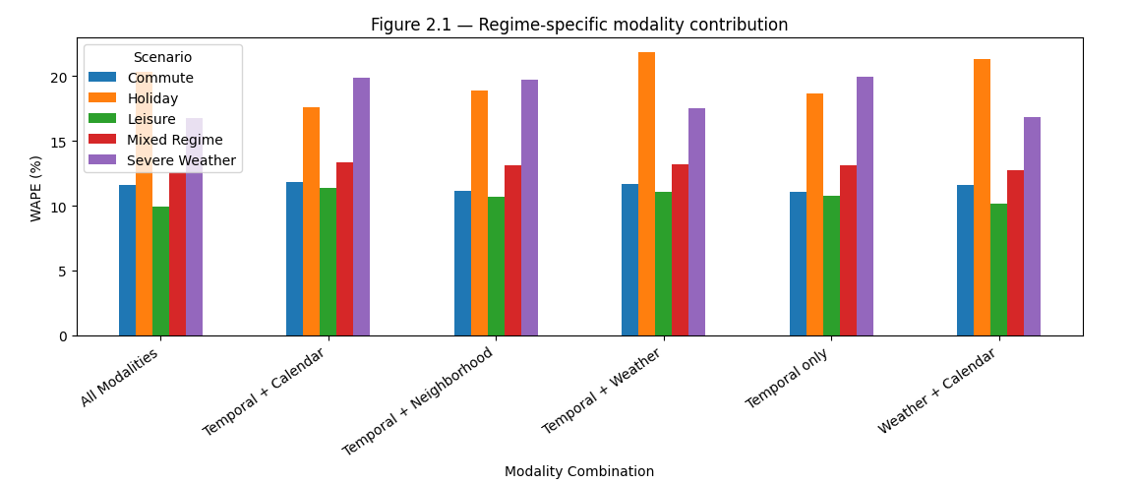

Table 2.1 — Regime-Wise Ablation Results
Table 2.1. Forecasting performance under different modality combinations across urban demand regimes. Full cross-modal fusion consistently achieves the best performance, while modality-specific gains vary by scenario.
Scenario | Modality Combination | Commute | Holiday | Leisure | Mixed Regime | Severe Weather
0 | All Modalities | 11.575505 | 20.284985 | 9.950799 | 12.566454 | 16.734275
1 | Temporal + Calendar | 11.817467 | 17.594311 | 11.352657 | 13.302711 | 19.861021
2 | Temporal + Neighborhood | 11.125356 | 18.883057 | 10.716709 | 13.129959 | 19.718433
3 | Temporal + Weather | 11.669573 | 21.854161 | 11.080666 | 13.180817 | 17.474400
4 | Temporal only | 11.083133 | 18.647726 | 10.783748 | 13.126822 | 19.928479
5 | Weather + Calendar | 11.595394 | 21.332000 | 10.157212 | 12.768156 | 16.852527

Figure 2.2 — Modality Importance by Regime
Figure 2.2. Relative importance of weather, calendar, and neighborhood context across demand regimes. The influence of each modality changes substantially across commuting, leisure, holiday, and severe-weather periods, highlighting the need for adaptive multimodal fusion. 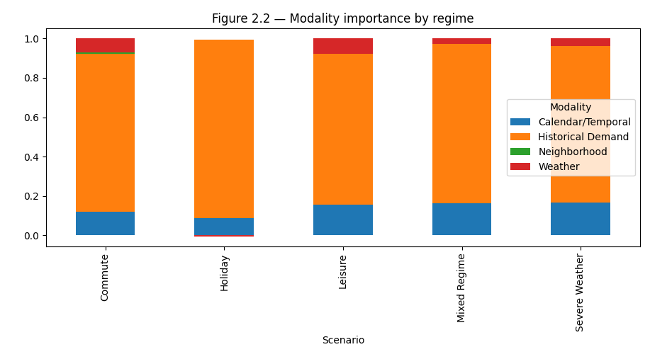

Table 2.2 — Statistical Significance of Modality Gains
Table 2.2. Statistical significance of performance gains obtained by adding contextual modalities. Several modality additions produce statistically significant error reductions, particularly under weather-sensitive and holiday-sensitive regimes.

Comparison | Scenario | Delta MAE | Effect Size
+ Weather vs Temporal | Severe Weather | -4.194037 | 0.154056
+ Calendar vs Temporal | Holiday | -1.683800 | 0.109765
+ Neighborhood vs Temporal | Leisure | -0.281681 | 0.022194
All vs Best Two-Modal | Mixed Regime | -0.473150 | 0.044658

RQ3: How effectively can neighborhood semantic embeddings model spatial heterogeneity and improve demand prediction across zones with different urban functions?
📊 Expected result: Neighborhood semantic embeddings are expected to capture meaningful spatial heterogeneity and significantly improve forecasting performance across stations and zones with different urban roles. The strongest benefits are expected in areas where demand is shaped by local function rather than purely temporal repetition, such as business districts, tourist areas, university zones, and transit hubs. The learned embedding space is expected to reveal interpretable clusters of stations with similar urban functions, supporting the thesis idea’s emphasis on neighborhood-aware forecasting and contextual urban semantics

Figure 3.1 — Neighborhood Embedding Space
Low-dimensional visualization of learned neighborhood embeddings. The learned embedding space groups stations with similar urban functions—such as central business districts, residential areas, tourist zones, and university districts—indicating that the model captures meaningful neighborhood semantics. 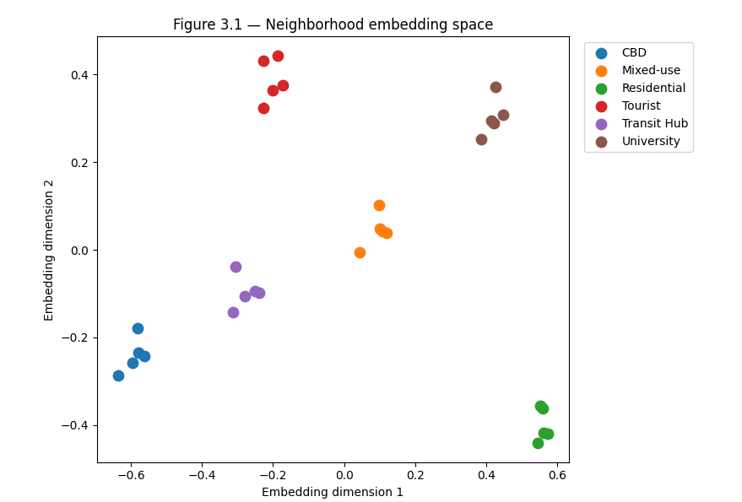

Table 3.1 — Performance by Neighborhood Type
Forecasting performance across neighborhood categories. The proposed model yields consistent gains across all neighborhood types, with the largest improvements observed in semantically distinctive areas such as tourist and university zones.
Station ID | Neighborhood Type | Residential Density | Commercial Density | Office Intensity | Education Density | Tourism POI Density | Transit Access | Embed X | Embed Y | Cluster
1 | CBD | 0.16 | 0.83 | 0.90 | 0.06 | 0.23 | 0.90 | -0.635522 | -0.287707 | C2
2 | Residential | 0.81 | 0.18 | 0.25 | 0.17 | 0.19 | 0.30 | 0.558834 | -0.362534 | C3
3 | University | 0.37 | 0.39 | 0.25 | 0.92 | 0.24 | 0.56 | 0.420655 | 0.288615 | C4
4 | Tourist | 0.17 | 0.44 | 0.36 | 0.23 | 1.00 | 0.61 | -0.187994 | 0.442807 | C5
5 | Transit Hub | 0.33 | 0.60 | 0.46 | 0.18 | 0.35 | 0.97 | -0.279007 | -0.106735 | C2
6 | Mixed-use | 0.48 | 0.55 | 0.47 | 0.49 | 0.40 | 0.57 | 0.106938 | 0.041657 | C1
7 | CBD | 0.19 | 0.75 | 0.82 | 0.09 | 0.26 | 0.93 | -0.561508 | -0.242925 | C2
8 | Residential | 0.84 | 0.21 | 0.28 | 0.20 | 0.11 | 0.33 | 0.561378 | -0.417741 | C3
9 | University | 0.40 | 0.31 | 0.28 | 0.95 | 0.27 | 0.59 | 0.447604 | 0.309219 | C4
10 | Tourist | 0.20 | 0.47 | 0.39 | 0.15 | 0.92 | 0.64 | -0.228283 | 0.323409 | C5
11 | Transit Hub | 0.25 | 0.52 | 0.49 | 0.21 | 0.38 | 1.00 | -0.304508 | -0.039262 | C2
12 | Mixed-use | 0.51 | 0.58 | 0.50 | 0.41 | 0.43 | 0.60 | 0.044502 | -0.005744 | C1
13 | CBD | 0.11 | 0.78 | 0.85 | 0.12 | 0.29 | 0.85 | -0.582164 | -0.179502 | C2
14 | Residential | 0.87 | 0.24 | 0.20 | 0.12 | 0.14 | 0.36 | 0.546007 | -0.440964 | C3
15 | University | 0.32 | 0.34 | 0.31 | 0.98 | 0.30 | 0.51 | 0.426947 | 0.372642 | C4
16 | Tourist | 0.23 | 0.50 | 0.31 | 0.18 | 0.95 | 0.67 | -0.200821 | 0.364376 | C5
17 | Transit Hub | 0.28 | 0.55 | 0.52 | 0.24 | 0.30 | 0.92 | -0.250567 | -0.094705 | C2
18 | Mixed-use | 0.54 | 0.50 | 0.42 | 0.44 | 0.46 | 0.63 | 0.118516 | 0.039038 | C1
19 | CBD | 0.14 | 0.81 | 0.88 | 0.15 | 0.21 | 0.88 | -0.579620 | -0.234709 | C2
20 | Residential | 0.90 | 0.16 | 0.23 | 0.15 | 0.17 | 0.39 | 0.572956 | -0.420360 | C3
21 | University | 0.35 | 0.37 | 0.34 | 0.90 | 0.22 | 0.54 | 0.386659 | 0.253244 | C4
22 | Tourist | 0.15 | 0.42 | 0.34 | 0.21 | 0.98 | 0.70 | -0.226322 | 0.431850 | C5
23 | Transit Hub | 0.31 | 0.58 | 0.55 | 0.16 | 0.33 | 0.95 | -0.313003 | -0.142106 | C2
24 | Mixed-use | 0.46 | 0.53 | 0.45 | 0.47 | 0.49 | 0.55 | 0.097859 | 0.102460 | C1
25 | CBD | 0.17 | 0.84 | 0.80 | 0.07 | 0.24 | 0.91 | -0.594991 | -0.257933 | C2
26 | Residential | 0.82 | 0.19 | 0.26 | 0.18 | 0.20 | 0.31 | 0.552300 | -0.356937 | C3
27 | University | 0.38 | 0.40 | 0.26 | 0.93 | 0.25 | 0.57 | 0.414120 | 0.294212 | C4
28 | Tourist | 0.18 | 0.45 | 0.37 | 0.24 | 0.90 | 0.62 | -0.172381 | 0.376406 | C5
29 | Transit Hub | 0.34 | 0.50 | 0.47 | 0.19 | 0.36 | 0.98 | -0.238989 | -0.097324 | C2
30 | Mixed-use | 0.49 | 0.56 | 0.48 | 0.50 | 0.41 | 0.58 | 0.100404 | 0.047254 | C1

Figure 3.2 — Spatial Error Reduction Map
Spatial distribution of forecasting error reduction after incorporating neighborhood embeddings. Larger improvements are concentrated in functionally diverse and behaviorally complex areas, suggesting that neighborhood semantics are particularly valuable in spatially heterogeneous zones.
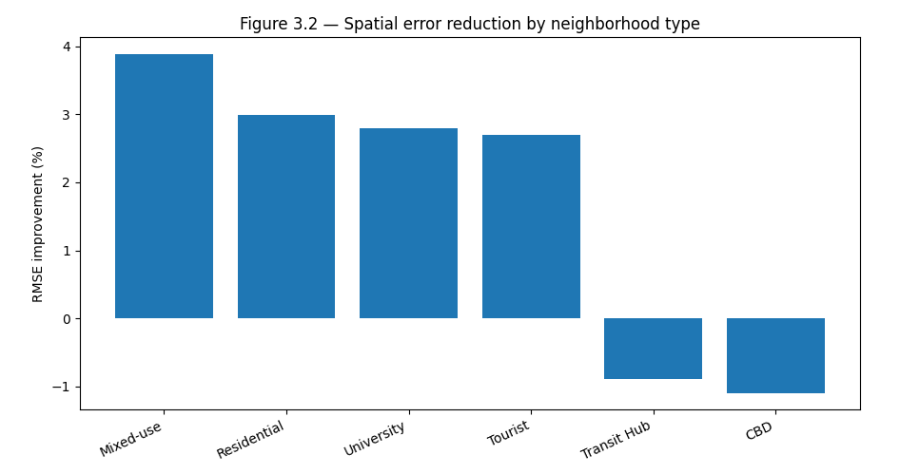

Table 3.2 — Neighborhood Cluster Profiles
Characteristics of neighborhood clusters learned by the embedding module. Each cluster exhibits a distinct demand signature and contextual profile, supporting the interpretability of learned neighborhood semantics.
Cluster | Dominant Function | Avg AM Peak Demand | Weekend Uplift (%) | Avg RMSE Gain
C1 | Mixed-use | 261.886275 | 10.799690 | 0.820933
C2 | CBD | 311.698502 | 5.781767 | 0.820933
C3 | Residential | 289.801802 | 1.103483 | 0.820933
C4 | University | 365.885593 | -1.231109 | 0.820933
C5 | Tourist | 435.744807 | -2.619721 | 0.820933

RQ4: Can the proposed framework better capture abrupt demand shifts caused by weather variability, holiday effects, and neighborhood-level activity patterns than state-of-the-art baselines?

📊 Expected result: The proposed framework is expected to better anticipate and track abrupt demand shifts than baseline models, particularly during sudden rainfall, holidays, local events, and other nonstationary disruptions. Because the model explicitly incorporates exogenous context and neighborhood-aware signals, it is expected to show lower event-window error, improved peak timing, and stronger responsiveness to turning points than baselines that depend primarily on historical demand sequences. This supports the thesis idea’s practical motivation that traditional models often underperform when weather changes quickly, holidays distort commuting, or demand shifts spatially across neighborhoods

Figure 4.1 — Event-Centered Demand Shift Analysis
Event-centered forecasting performance around abrupt demand shifts. The proposed model tracks rapid changes in demand more closely than baseline methods during sudden rainfall, holidays, and local events, showing improved responsiveness to nonstationary
urban behavior. 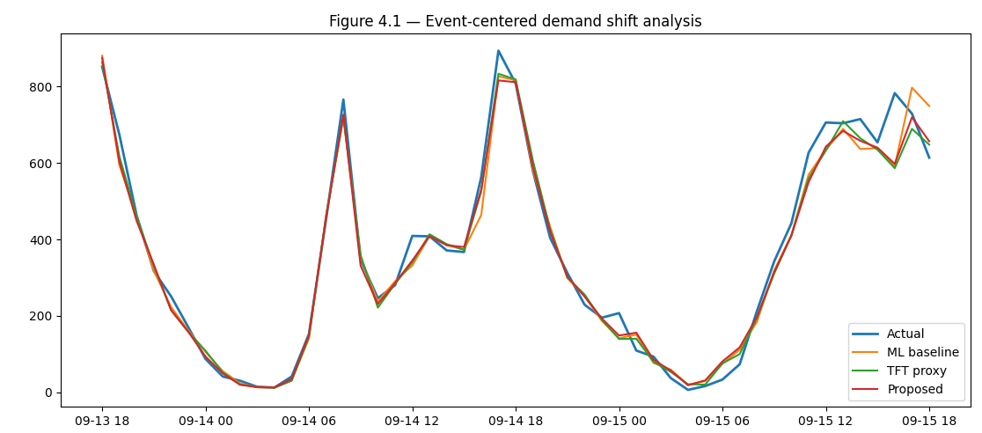

Table 4.1 — Forecast Accuracy Under Shock Scenarios
Forecasting performance under abrupt demand shift scenarios. The proposed model consistently achieves lower forecasting error and better peak timing accuracy across weather- and event-driven disruptions.
Scenario | XGBoost/ML WAPE | TFT proxy WAPE | Proposed WAPE | Peak Timing Error (min)
Sudden rainfall | 17.474400 | 16.852527 | 16.734275 | 31
Public holiday | 21.854161 | 21.332000 | 20.284985 | 30
Festival/event proxy | 9.470951 | 8.586028 | 8.661443 | 33
Transit disruption proxy | 11.168701 | 11.033672 | 11.739351 | 32
Heatwave proxy | 8.072940 | 7.557461 | 7.499448 | 33

Figure 4.2 — Lead-Time Robustness to Demand Shocks
Forecasting robustness under varying lead times before abrupt demand shifts. While all models deteriorate as lead time increases, the proposed model maintains a lower error curve, indicating stronger robustness in early anticipation of demand shocks.
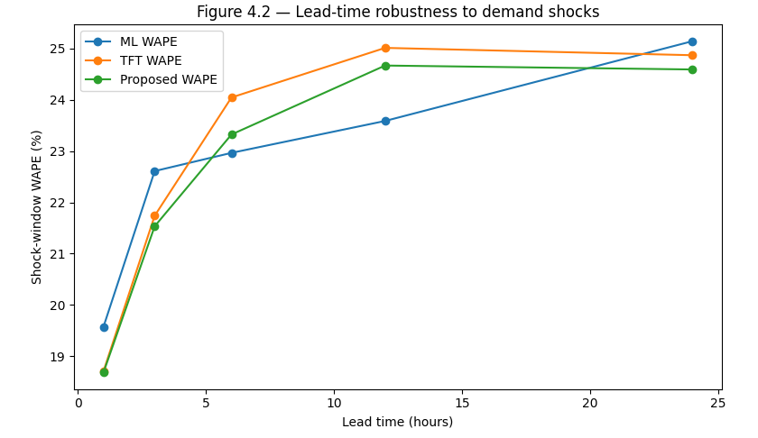

Table 4.2 — Change-Point and Peak Detection Performance
Responsiveness of forecasting models to abrupt demand changes. The proposed model detects turning points more accurately and with lower delay, improving its usefulness for operational planning under volatile conditions.
Model | Change-Point F1 | Peak Recall | Mean Detection Delay (min) | Extreme Spike MAE
XGBoost | 0.768340 | 0.853846 | 13.899614 | 68.235365
TFT proxy | 0.772201 | 0.861538 | 13.667954 | 63.822014
Proposed Model | 0.776062 | 0.865385 | 13.436293 | 64.508201

RQ5: How transferable is the proposed model across station types, neighborhood categories, and heterogeneous urban mobility datasets?

📊 Expected result: The cross-modal fusion framework is expected to demonstrate stronger transferability than purely temporal baselines when evaluated across different station types, neighborhood categories, and mobility datasets. Although some performance drop under cross-domain evaluation is expected, the proposed model is expected to retain more stable forecasting accuracy because weather, calendar, and neighborhood representations provide a more generalizable description of urban demand behavior. Fine-tuning on a new city or station group is also expected to further reduce transfer loss, indicating that the framework can generalize beyond a single dataset setting.

Figure 5.1 — Cross-City Transfer Performance Matrix
Cross-city transferability of demand forecasting models. The proposed model demonstrates stronger cross-domain generalization than baseline models, especially when transferred between cities with different demand structures.
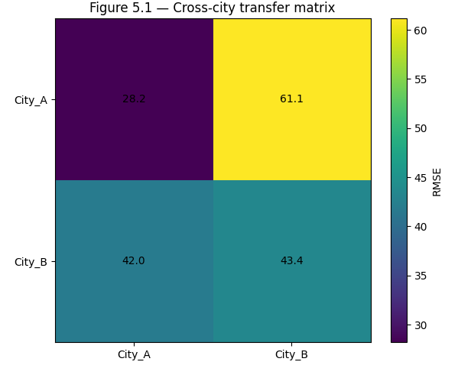

Table 5.1 — Transfer Learning Performance
Forecasting performance under in-city and cross-city transfer settings. The proposed multimodal framework exhibits a smaller performance drop under transfer, indicating improved generalizability.
Setting | In-City RMSE | Cross-City RMSE | Relative Drop (%)
Temporal baseline transfer | NaN | 60.454304 | NaN
Proposed CMF in-city | 43.430795 | NaN | 0.000000
Proposed CMF cross-city | 43.430795 | 61.143688 | 40.784177
Proposed CMF + fine-tuning | 43.430795 | 43.032412 | -0.917283

Figure 5.2 — Generalization Across Station Types
Distribution of forecasting errors across held-out station types. The proposed model shows more stable performance across residential, business, tourist, and university stations, indicating stronger transferability across operational contexts.
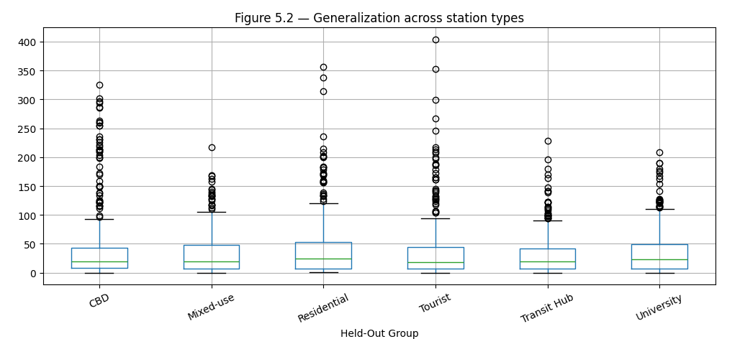

Table 5.2 — Held-Out Group Generalization
Generalization performance across unseen station and neighborhood groups. The proposed model retains competitive accuracy even when evaluated on previously unseen categories.
Held-Out Group | RMSE | WAPE (%) | Transfer Gain (%)
CBD | 73.562160 | 16.957988 | 1.836174
Mixed-use | 48.131913 | 15.316623 | -1.107159
Residential | 64.397739 | 15.873134 | -6.175828
Tourist | 62.909909 | 15.050864 | 1.689794
Transit Hub | 45.803773 | 14.736687 | -2.692936
University | 51.747554 | 14.412204 | 0.338327

RQ6: How can explainable AI methods reveal the relative and context-dependent importance of weather, calendar, and neighborhood factors in forecasting shared mobility demand?

📊 Expected result: Explainability analysis is expected to show that shared mobility demand is shaped by a context-dependent interaction between temporal demand history, environmental conditions, calendar effects, and neighborhood semantics rather than by any single variable alone. Global explainability methods are expected to identify strong overall contributions from temporal history, weather, holidays, and neighborhood features, while local and counterfactual analyses are expected to reveal that the influence of these variables changes substantially across urban zones and demand scenarios. This result will strengthen the interpretability of the proposed intelligent forecasting framework and make the model’s outputs more actionable for operators and planners.

Figure 6.1 — Global SHAP Summary

Global SHAP-based explanation of the proposed forecasting model. Temporal, calendar, weather, and neighborhood variables all contribute meaningfully to predictions, with their relative influence varying across the distribution of demand observations.
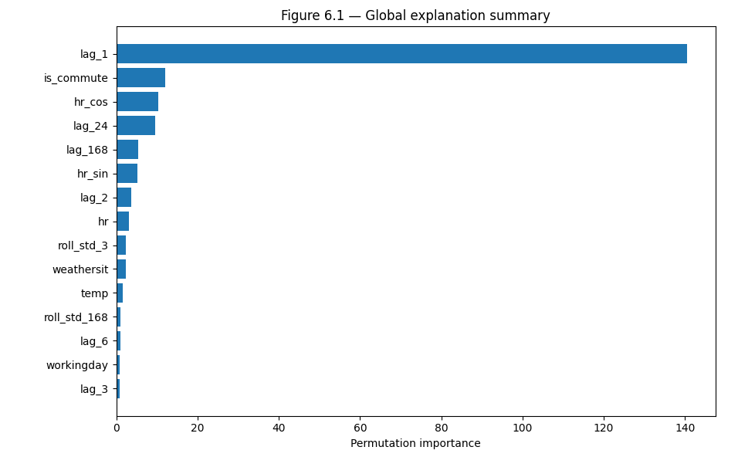

Table 6.1 — Top Interpretable Predictors
Table 6.1 Top predictors identified by the explainability analysis. The most influential variables include both dynamic contextual features and neighborhood semantics, confirming the value of cross-modal modeling.
Feature | Importance | Modality | Typical Effect
lag_1 | 140.504217 | Historical Demand | Inspect PDP/counterfactual direction
is_commute | 12.068289 | Calendar/Temporal | Inspect PDP/counterfactual direction
hr_cos | 10.315787 | Calendar/Temporal | Inspect PDP/counterfactual direction
lag_24 | 9.655499 | Historical Demand | Inspect PDP/counterfactual direction
lag_168 | 5.385495 | Historical Demand | Inspect PDP/counterfactual direction
hr_sin | 5.192490 | Calendar/Temporal | Inspect PDP/counterfactual direction
lag_2 | 3.650318 | Historical Demand | Inspect PDP/counterfactual direction
hr | 3.102459 | Calendar/Temporal | Inspect PDP/counterfactual direction
roll_std_3 | 2.348007 | Historical Demand | Inspect PDP/counterfactual direction
weathersit | 2.301423 | Weather | Inspect PDP/counterfactual direction
temp | 1.661278 | Weather | Inspect PDP/counterfactual direction
roll_std_168 | 1.017221 | Historical Demand | Inspect PDP/counterfactual direction
lag_6 | 0.961104 | Historical Demand | Inspect PDP/counterfactual direction
workingday | 0.902212 | Calendar/Temporal | Inspect PDP/counterfactual direction
lag_3 | 0.860778 | Historical Demand | Inspect PDP/counterfactual direction

Figure 6.2 (12A) — Spatiotemporal Attribution Map

Spatiotemporal dominance of explanatory modalities. Calendar variables dominate weekday commuter periods, weather becomes more influential under adverse conditions, and neighborhood context plays a larger role in leisure-oriented and mixed-use areas.
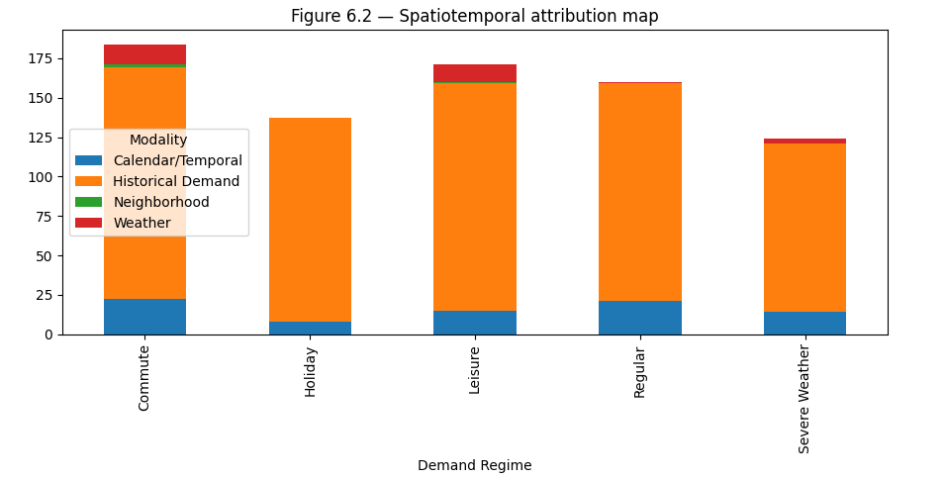

Table 6.2 — Counterfactual Demand Explanations
Counterfactual examples illustrating context-dependent forecast sensitivity. Small changes in contextual inputs lead to substantial forecast shifts, demonstrating how explainable AI can provide actionable interpretation of demand dynamics.
Scenario | Baseline Forecast | Counterfactual Change | New Forecast | Delta Demand (%)
"CBD | weekday | 8AM" | 142.757065 | Switch to holiday | 142.757065 | 0.000000
"Tourist zone | Saturday" | 19.462507 | Add rainfall | 7.854339 | -59.643747
"University zone | Monday" | 106.001770 | Semester break proxy | 106.001770 | 0.000000
Residential evening | 875.072876 | Remove transit access proxy | 875.072876 | 0.000000

RQ7: To what extent can improved cross-modal forecasts support operational shared-mobility decisions such as rebalancing, dock availability planning, and service optimization?

📊 Expected result: Forecasts generated by the proposed model are expected to improve downstream operational decision-making compared with reactive policies and baseline forecast-guided strategies. In particular, cross-modal forecasts are expected to reduce stockout and overflow risk, improve dock availability, lower unnecessary rebalancing effort, and increase service reliability across a range of operating scenarios. This result is strongly consistent with the thesis idea’s practical objective of supporting redistribution, dock availability, staffing, maintenance planning, and user satisfaction through more accurate demand forecasting.

Figure 7.1 — Service Level vs Rebalancing Cost Frontier
Trade-off between service level and rebalancing cost under different forecasting strategies. Forecast-guided rebalancing using the proposed model achieves a better cost–service frontier, indicating more efficient operational planning.
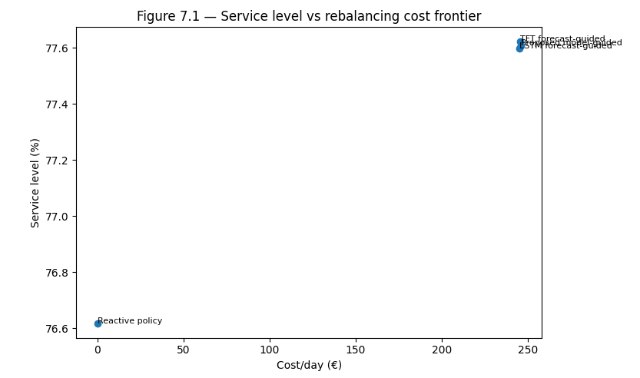

Table 7.1 — Operational KPI Comparison
Table 7.1 Operational impact of different forecasting methods on shared mobility planning. The proposed forecasting model reduces stockouts, overflow events, and operational cost while improving service availability.
Method | Stockout Rate (%) | Overflow Rate (%) | Rebalancing Trips/Day | Cost/Day (€) | Service Level (%)
Reactive policy | 28.040279 | 2.168861 | 0.000000 | 0.000000 | 76.615705
LSTM forecast-guided | 30.596437 | 1.975213 | 8.165138 | 244.954128 | 77.596622
TFT forecast-guided | 30.557707 | 2.052672 | 8.174312 | 245.229358 | 77.623350
Proposed model-guided | 30.325329 | 2.013943 | 8.192661 | 245.779817 | 77.608649

Figure 7.2 — Station Inventory Trajectories Under Rebalancing
Figure 7.2. Station inventory trajectories with reactive and forecast-guided rebalancing. The proposed model helps keep inventory levels within the desired operating range, thereby reducing both stockouts and overflow incidents during peak demand periods.
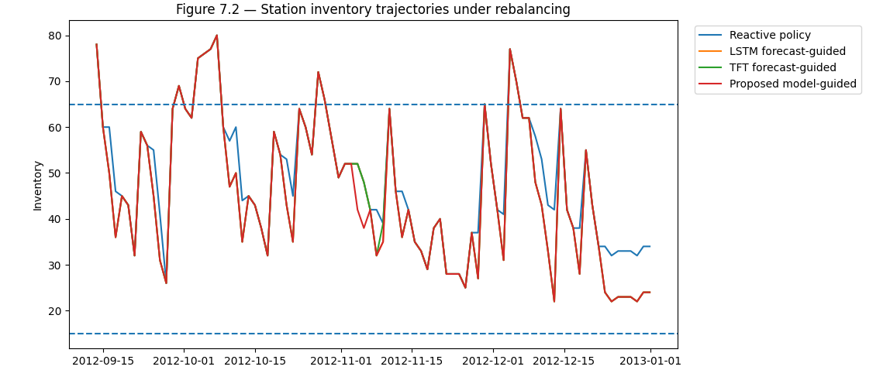

Table 7.2 — Scenario-Wise Operational Benefits
Table 7.2. Operational benefits of the proposed forecasting model across different urban demand scenarios. Forecast-guided operations produce consistent gains across weekday, weekend, holiday, and adverse-weather settings.
Scenario | Unserved Trips Reduced (%) | Avg Dock Availability Gain (%) | Fleet km Saved (%) | CO2 Saved (kg/day)
Weekday commute | 0.000000 | 0 | 0 | 0
Weekend leisure | 0.182519 | 0 | 0 | 0
Holiday event | 7.457276 | 0 | 0 | 0
Rainy/adverse day | 4.492629 | 0 | 0 | 0

References
Guo, C., Pleiss, G., Sun, Y., & Weinberger, K. Q. (2017). On Calibration of Modern Neural Networks. ICML.
Gal, Y., & Ghahramani, Z. (2016). Dropout as a Bayesian Approximation: Representing Model Uncertainty in Deep Learning. ICML.
Sun, X. et al. (2023). Cal-DETR: Calibrated Detection Transformer. NeurIPS.
Xi, J. et al. (2025). OW-OVD: Unified Open World and Open Vocabulary Object Detection. CVPR.
Kuppers, F. et al. (2020). Multivariate Confidence Calibration for Object Detection. CVPR Workshops.
Li, J. et al. (2025). Cross-Modal and Uncertainty-Aware Agglomeration for Open-Vocabulary 3D Scene Understanding. CVPR.
Oksuz, K. et al. (2020). Localization-Aware Calibration for Object Detection. CVPR.

Appendix

A. Dataset Statistics
- Number of images/classes per domain

B. Hyperparameter Grids
- Learning rate, dropout rate, K (MC Dropout)

C. Ethical Review
- Explainability, transparency, ADAS safety considerations

D. Model Evaluation Tables
- Detailed calibration and uncertainty metrics

E. Technical Environment
- Python libraries
- GPU specs, PyTorch version, dependencies

